***Chemistry***

**18: Representative Metals, Metalloids, and Nonmetals**

**18.3: Structure and General Properties of the Metalloids**

29. Write a Lewis structure for each of the following molecules or ions. You may wish to review the chapter on chemical bonding.

(a) H3BPH3

(b) 

(c) BBr3

(d) B(CH3)3

(e) B(OH)3

Solution

(a) H3BPH3:

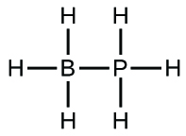;

(b) :

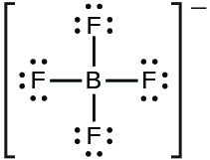;

(c) BBr3 :

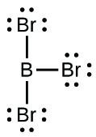;

(d) B(CH3)3:

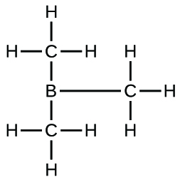;

(e) B(OH)3:

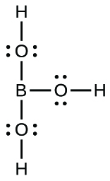

31. Using only the periodic table, write the complete electron configuration for silicon, including any empty orbitals in the valence shell. You may wish to review the chapter on electronic structure.

Solution

1*s*22*s*22*p*63*s*23*p*23d0. The detailed configuration for the valence shell is:

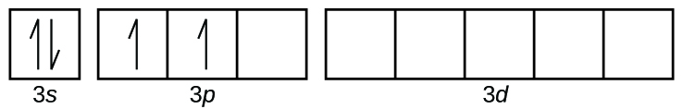

33. Describe the hybridization of silicon and the molecular structure of the following molecules and ions:

(a) (CH3)3SiH

(b) 

(c) Si2H6

(d) Si(OH)4

(e) 

Solution

(a) (CH3)3SiH: *sp*3 bonding about Si; the structure is tetrahedral; (b) : *sp*3 bonding about Si; the structure is tetrahedral; (c) Si2H6: *sp*3 bonding about each Si; the structure is linear along the Si-Si bond; (d) Si(OH)4: *sp*3 bonding about Si; the structure is tetrahedral; (e) : *sp*3*d*2 bonding about Si; the structure is octahedral

35. Classify each of the following molecules as polar or nonpolar. You may wish to review the chapter on chemical bonding.

(a) SiH4

(b) Si2H6

(c) SiCl3H

(d) SiF4

(e) SiCl2F2

Solution

(a) nonpolar; (b) nonpolar; (c) polar; (d) nonpolar; (e) polar

37. Name each of the following compounds:

(a) TeO2

(b) Sb2S3

(c) GeF4

(d) SiH4

(e) GeH4

Solution

(a) tellurium dioxide or tellurium(IV) oxide; (b) antimony(III) sulfide; (c) germanium(IV) fluoride; (d) silane or silicon(IV) hydride; (e) germanium(IV) hydride

39. Why is boron limited to a maximum coordination number of four in its compounds?

Solution

Boron has only *s* and *p* orbitals available, which can accommodate a maximum of four electron pairs. Unlike silicon, no *d* orbitals are available in boron.

41. From the data given in Appendix I, determine the standard enthalpy change and the standard free energy change for each of the following reactions:

(a) 

(b) 

(c) 

Solution

(a) 



Δ*G*° = –969.01 + 2(–273) – (–1120.3) – 3(–237.18) = 44 kJ;

(b) 



Δ*G°* = –969.01 + 3(–95.299) – (–388.7) – 3(–237.18) = –154.7 kJ;

(c) 



Δ*G*° = 2(–969.01) + 0 – 86.6 – 6(–237.18) = –601.5 kJ

43. Suppose you discovered a diamond completely encased in a silicate rock. How would you chemically free the diamond without harming it?

Solution

A mild solution of hydrofluoric would dissolve the silicate and would not harm the diamond.

This resource file is copyright 2015, Rice University. All Rights Reserved.